**IFT 266 Introduction to Network Information Communication Technology (ICT)   
  
Lab 36**

**IPv6 over IPv4­­­ in Theory and in Practice**

Co-authored by Michael Ycedo + Kamakshi Rajan

**Part 1: Theory**

**The Current Problem**

In this lab we will review many advantages that have come with the innovation of IPv6. The primary advantage is the most obvious and attempts to solve the problem we currently find with IPv4. Explain this problem in as simple a sentence as possible.

**Basic Structure**

Next we will review the basic data structures (addresses) of IPv4 vs IPv6.

How many bits represent a IPv4 address and an IPv6 address

IPv4 🡪 bits IPv6 🡪 bits

So, what’s the difference beside the number of bits? Well, quite a bit (pun intended!).   
  
First, we begin with the header.   
  
We observe some basic differences before diving into the exact formation.

Answer the following the following questions below.

1. Which IP has longer headers? ____________
2. By how much? ______________
3. Which IP has variable headers? ___________
4. Which has more fields? __________
5. Which is simpler for both human readability and computer processing? ___________

**Protocol Headers**

**IPv4 Header (160 bits, 20 bytes)**

|  |  |  |  |  |
| --- | --- | --- | --- | --- |
| Version (4) | Header Length (4) | Type of Service (8) | Total Length (16) | |
| Identification (16) | | | Flags (3) | Fragment Offset (13) |
| Time to Live (8) | | Protocol Number (8) | Header Checksum (16) | |
| Source Address (32) | | | | |
| Destination Address (32) | | | | |

**IPv6 Header (320 bits, 40 bytes)**

|  |  |  |  |
| --- | --- | --- | --- |
| Version (4) | Traffic Class (8) | Flow Label (20) | |
| Payload Length (16) | | Next Header (8) | Hop Limit (8) |
| Source Address (128) | | | |
| Destination Address (128) | | | |

The exact fields and their length in bits are given to you as you are not expected to memorize them at this stage of learning. You should, however, be able to distinguish what their function is and what has been transferred from IPv4 to IPv6, and what is no longer necessary.

There is only one field that is unique to IPv6 headers. What is it?   
  
  
__________________________

**More IPv6 Advantages**

Pick the true statements from the following group by **circling** true or false for each statement

1. Because of smaller address space, IPv4 is much less intensive on router processing power

True False

2. IPv4 has the ability to send out broadcast packets, which are intensive on bandwidth and router processing power.

True False

1. IPv4 is more secure than IPv6 because it allows for IPsec, but does not require it.  
     
   True False

1. IPv6 is more secure than IPv4 exactly because IPsec is required.  
     
     
   True False
2. Both IPv4 and IPv6 use DHCP, but IPv6’s version is much more advanced and user friendly.

True False  
  
  
6. ARP was replaced by the end-to-end model of internet.  
  
  
True False

7. NAT brought back Network Discovery Protocol.  
  
  
 True False

8. 6 and 7 are backwards. ARP was replaced by NDP and NAT was eliminated in favor of a return to end-to-end internet.  
  
   
 True False

1. IPv6 can use autoconfiguration by getting prefix information from the router and interface ID from the MAC address to make global IP address (es).  
     
     
    True False
2. Some of the stopgap measures to conserve addresses in IPV4 have been eliminated due to lack of need. These include NAT and ARP, which complicated the process of network administration.

True False

**Part 2: Practice**

Configure following topologies in packet tracer.   
  
The topology on the top will be used for IPv6 while the topology below will be used for the IPv4.

**Topology A → IPv6**

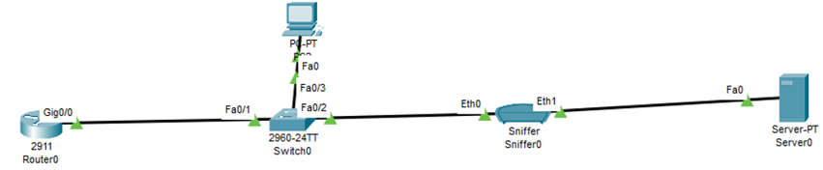

**Topology B → IPv4**

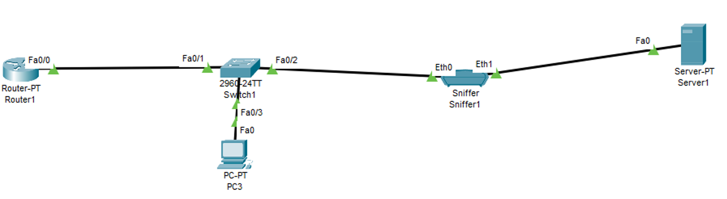



**Topology A (IPv6) – Configuration**

1. Router Configuration

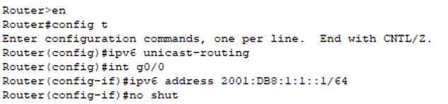

1. Configure both the PC and the server through IPv6 autoconfiguration.
2. Ping the Server from the PC to make sure the ping goes through. If not Troubleshoot.



1. Click on the sniffer in Topology A, click on GUI tab and click on Show All/None.   
     
   Then click on Edit Filters and make sure HTTP (Misc tab) is the only protocol checked on any tab.



1. Go to the web browser of the PC and type in the IPv6 address of the server followed by :80 as shown in the image below (you IPv6 address will differ) – you should see the Cisco website. If not troubleshoot.

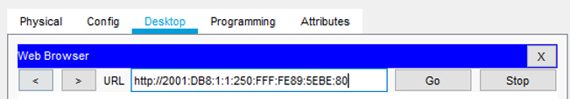



1. Now go to the sniffer device and go to the GUI, select http and you should see the IPv6 packet header.   
     
   Post the image of the packet header below

**Topology B (IPv4) – Configuration**

1. Router Configuration

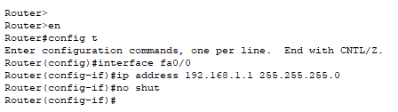



1. Enter the following addresses on the PC and Server in this topography. You can do it statically.

|  |  |  |  |
| --- | --- | --- | --- |
|  | **IP ADDRESS** | **SUBNET MASK** | **DEFAULT GATEWAY** |
| PC | 192.168.1.100 | 255.255.255.0 | 192.168.1.1 |
| SERVER | 192.168.1.254 | 255.255.255.0 | 192.168.1.1 |



1. ****Make sure you can ping the server from the PC, if not, troubleshoot.

1. ****Click on the sniffer then click on GUI tab and click on Show All/None.   
     
   Then click on Edit Filters and make sure HTTP (Misc tab) is the only protocol checked on any tab.
2. Go the web browser of the PC in this topography and type the address of the server and you will get the following result

****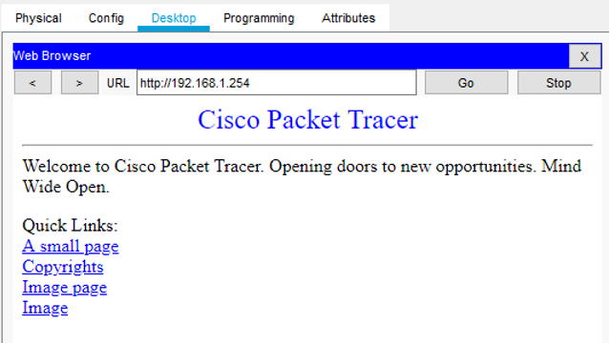

1. Now go to the sniffer device and go to the GUI, select http and you should see the IPv4 packet header.   
     
   Post the image of the packet header below

1. Now that you have both the packet headers, answer the following questions.

Name the fields kept in the IPV6 from IPV4   
(We cannot see Version on these, so ignore it because the Version field is common for both):

Name the fields that are in IPV4, but were not retained in Ipv4:

Name the fields whose names have been changed and position moved:

Name the field that is new to IPV6: